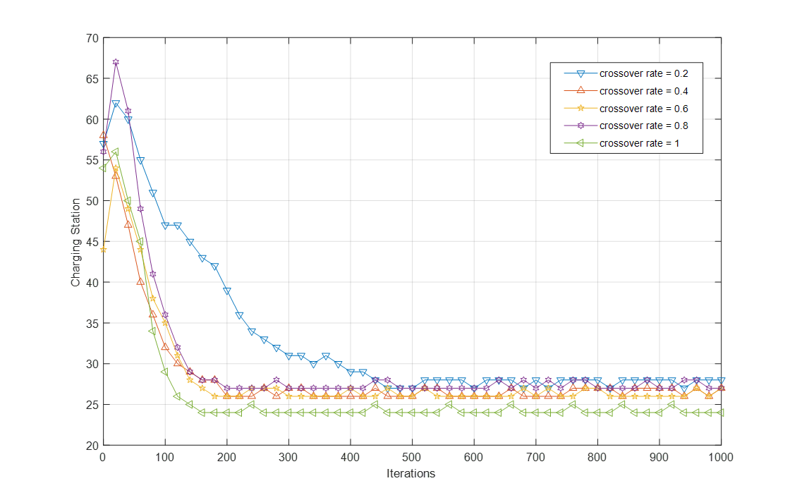

Figure 12. Effects of the crossover rate on NSGA-II convergence